**Names:** Edwin Zhang (zhan6577), Malhar Shah (Shahmal5)

**TA:** Wagih Ismail

**Lab:** Thursday 9 - 12

**Station:** 14

**Project Description:**

You are staying on your private island during the quarantine and you decided to go for a scuba dive. Suddenly you see and endless number of sharks! You need to swim your way through without touching or coming too close otherwise you can seriously get hurt! The waves are strong so you don’t have great control over your body, but you must do the best you can.

This game is an infinite runner, or in this case, an infinite “swimmer.” The sharks will randomly spawn for until the player dies by hitting the shark.

**Controls:**

Used W-A-S-D to move your character. Simply tapping is enough to make your character to move in a direction (Holding down overloads cpulator ps2 port). Make sure to type/enter W-A-S-D into the ps2 port with address **ff200100**. It is recommended that you drag the tab to be right under the VGA display as shown below. It is important to select the box **type here** before trying to move the player.

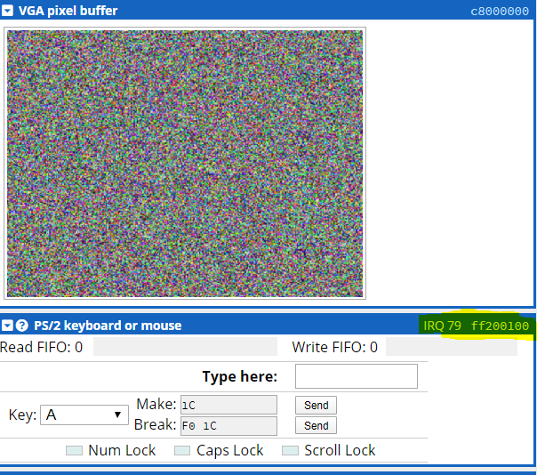

**How to load:**

Our project is done on CPUlator. Since CPUlator does not support multiple files, we have included all of our work in **main.c**. Simply **copy the entire file and paste it in cpulator in C mode.**

**Attribution table:**

The work done in this project is 50-50.

|  |  |
| --- | --- |
| **Malhar** | **Edwin** |
| * Player graphics * Background graphics * Obstacle graphics * Score | * Obstacle spawning algorithm * Player & obstacle movement * Player collision * Any data structure requirements ie. Player structs, linked list |